1. Excluded month, day. Included wday, hour, minute. Ntree = 1000, MSE = 4825.985, % var= 52.94

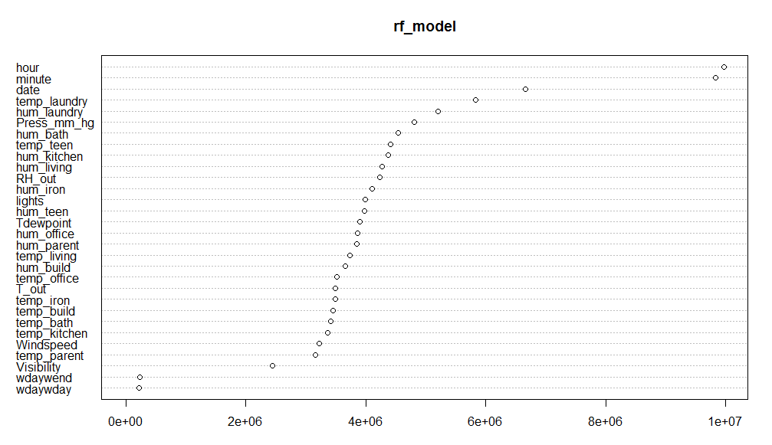

1. Excluded month, day, wday. MSE= 4843.18, % var= 52.77
2. Excluded month, day, wday, hour. MSE= 4873.99, % var= 52.47

